Scenario 1

a)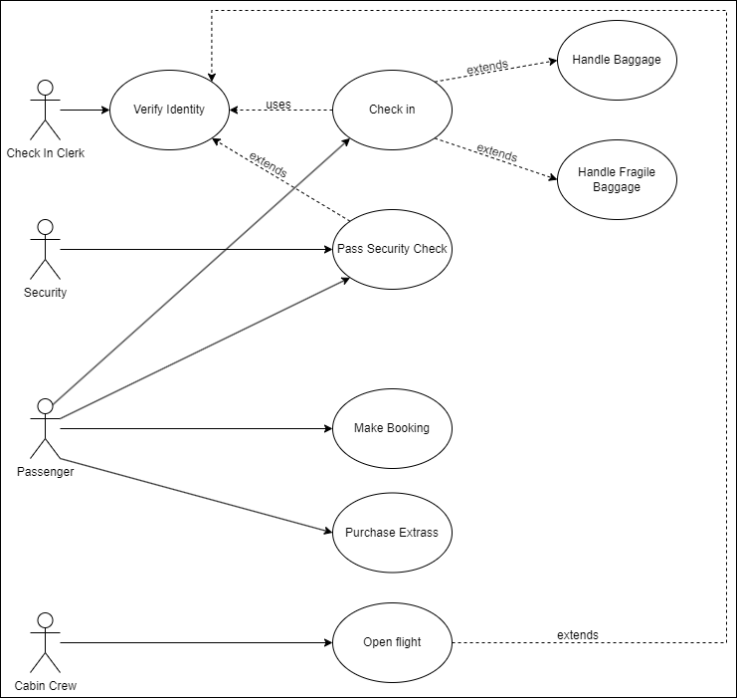

b)

|  |  |
| --- | --- |
| Use Case Documentation | |
| Author name(s): | Date of creation: |
| Roman Hrynchak | 24/09/2024 |
| System name: | FlyHigh Booking and Check-in System |
| Description of system: | FlyHigh is a low-cost airline offering customers the ability to book flights, check-in at airports, and purchase optional extras such as insurance or baggage allowance. Passengers must pass security and identity checks before boarding. |
| Use case name: | Use case number: |
| Make Booking | 001 |
| Initiating actors: | Receiving actors: |
| Passenger | System |
| Pre-conditions: | Passenger must access the FlyHigh booking system, usually through the website. They must have the flight details ready and the option to purchase additional services if needed. |
| List of scenarios and events |  |
| Normal scenarios | A passenger books a flight on the FlyHigh website by entering their flight details, selecting their preferred seat, and opting to purchase travel insurance and an additional baggage allowance. After successful payment, they receive a confirmation email with the flight details. On the day of the flight, the passenger arrives at the airport, checks in with a check-in clerk, and hands over their baggage. Airport security verifies their identity, and the passenger clears the security check without any issues. At the boarding gate, the cabin crew verifies their identity one final time, and the passenger boards the plane on time, proceeding to their seat as the flight prepares for departure. |
| Abnormal scenarios | A passenger attempts to book a flight, but the FlyHigh website experiences a system error during payment processing, causing the transaction to fail. The passenger tries again later, but finds that the flight they were booking is now fully booked. On the day of their flight, after managing to book a different one, they arrive late at the airport due to heavy traffic. At the check-in counter, they realize they have forgotten their identification. Despite explaining their situation to the check-in clerk, they are unable to check in without valid ID and are consequently unable to board the flight. |
| Assumptions | Passenger has access to the internet and sufficient payment means for booking. |
| Post–conditions | Passenger successfully makes the booking and receives confirmation of their flight. |

Scenario 2

a)

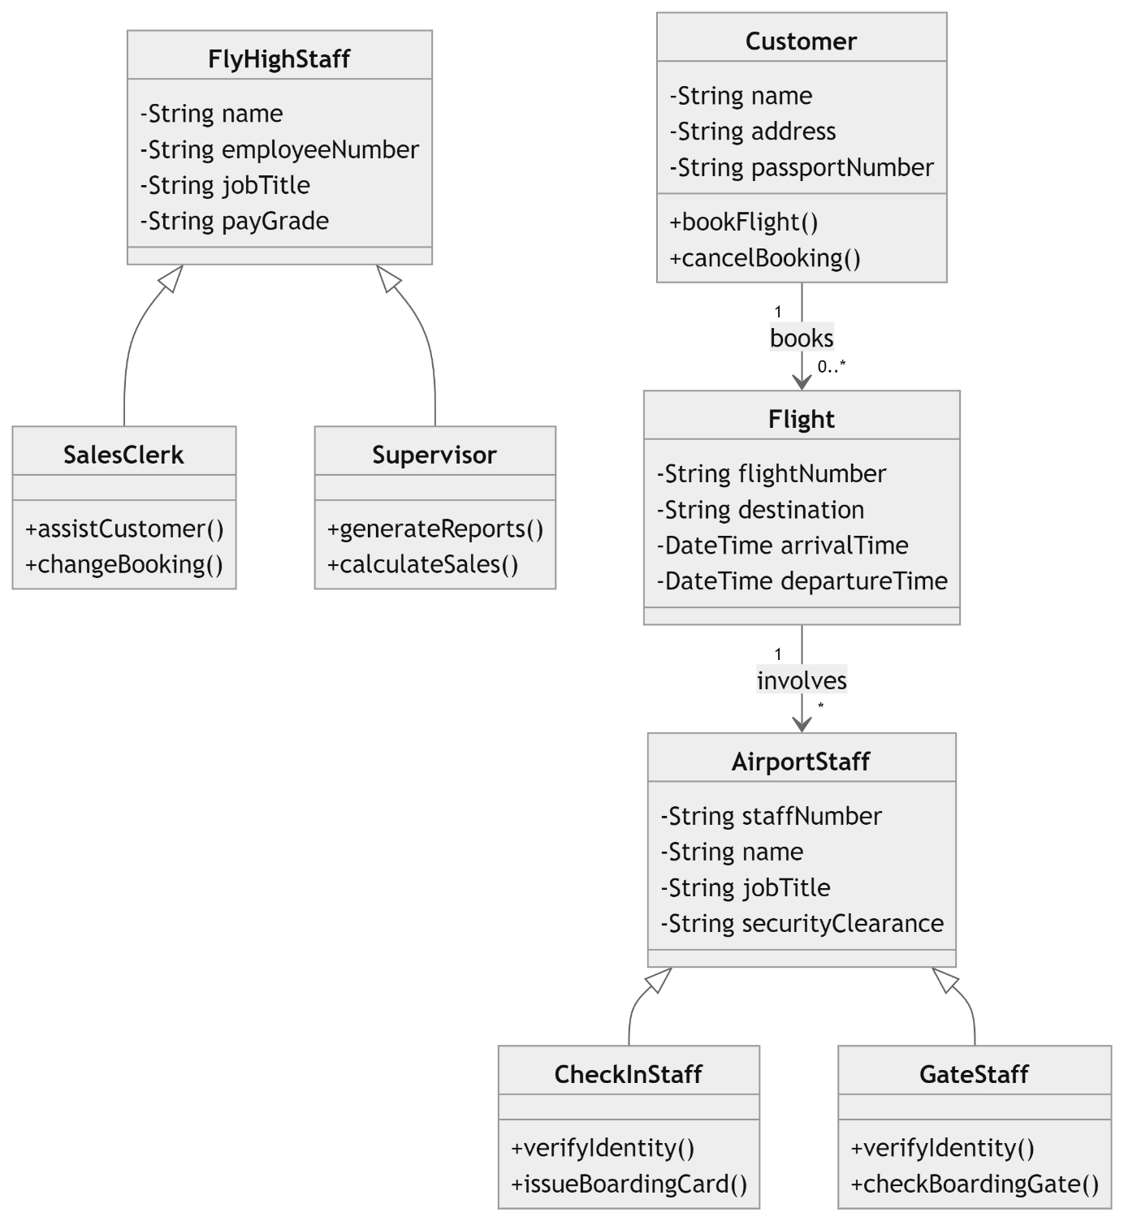

b)

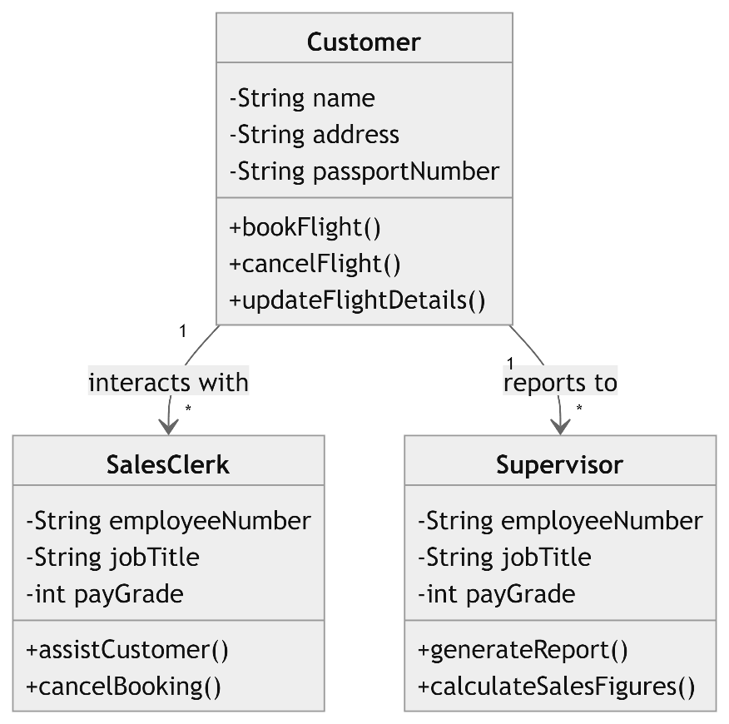

Scenario 3  
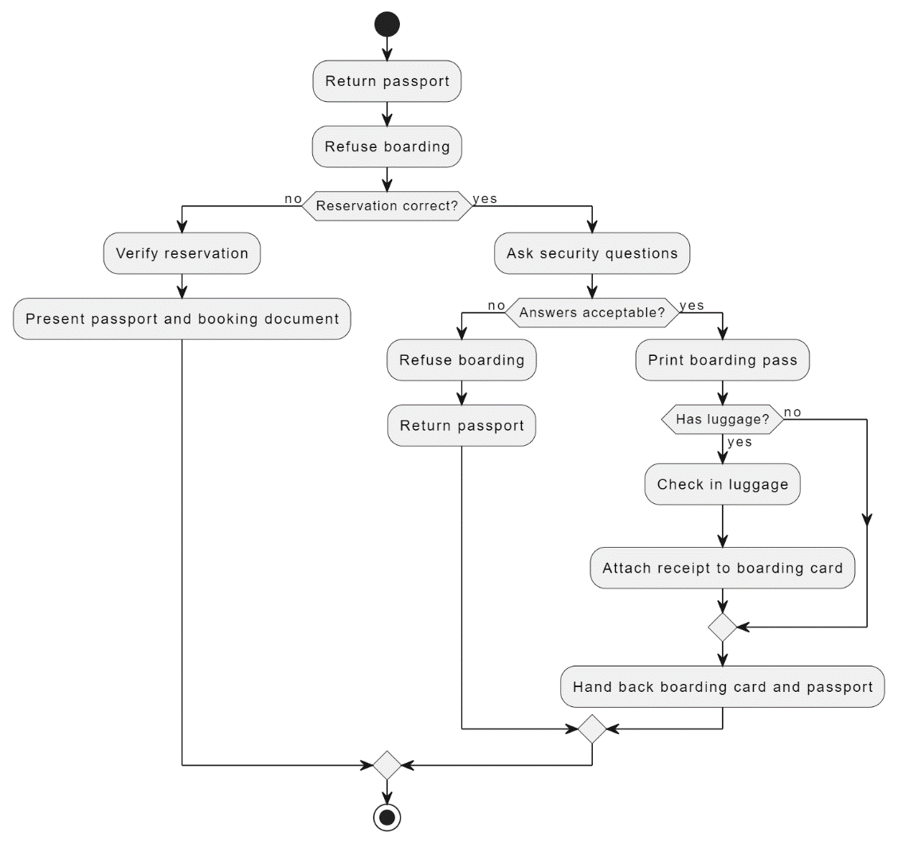

Scenario 4

